**

**Manchester Junior Chess**

**Manchester Juniors vs Jumping Knights, Edmonton**

**Sunday 17th May 2020**

|  |  |  |  |  |
| --- | --- | --- | --- | --- |
|  | **Play** | **MCF Club** |  | **Manchester Junior Chess** played the first of their international matches against Jumping Knights from Edmonton, Canada.  The match was played on Chess.com where Manchester holds a team.  The game was evenly balanced until the last couple of matches when they pulled ahead. The final score was 15.5-18.5  A return match is planned for later in the year.  C:\Users\Julian\AppData\Local\Microsoft\Windows\INetCache\Content.Outlook\N35QWON7\CANADA vs ENGLAND.png  The full results can be seen at the URL below.  During the match players met on a Zoom connection. |
| 1 | Thisum Jayawarna | Heywood | 0/2 |
| 2 | Edward Jackson | Three C's | 1/2 |
| 3 | Bryony Eccleston | Bolton | 0/2 |
| 4 | Tarini Jayawarna | Heywood | 0/2 |
| 5 | Josh Seet | Manchester | 1.5/2 |
| 6 | Gonzalo Rodrigo | Manchester | 0.5/2 |
| 7 | Stephen Nagai | Bolton | 0/2 |
| 8 | Rowan Eccleston | Bolton | 2/2 |
| 9 | William Fairclough | Bolton | 2/2 |
| 10 | Alexander Burke | Worsley | 2/2 |
| 11 | Darcy Casserley | Worsley | 0/2 |
| 12 | George Meredith | Bolton | 1.5/2 |
| 13 | Freddie Winser | Bolton | 1/2 |
| 14 | Shaurya Shaktawat | Bolton | 2/2 |
| 15 | Ben Saxby | Edgworth | 1/2 |
| 16 | Matthew Pearson | Bolton | 0/2 |
| 17 | Rufus Turner | Edgworth | 1/2 |

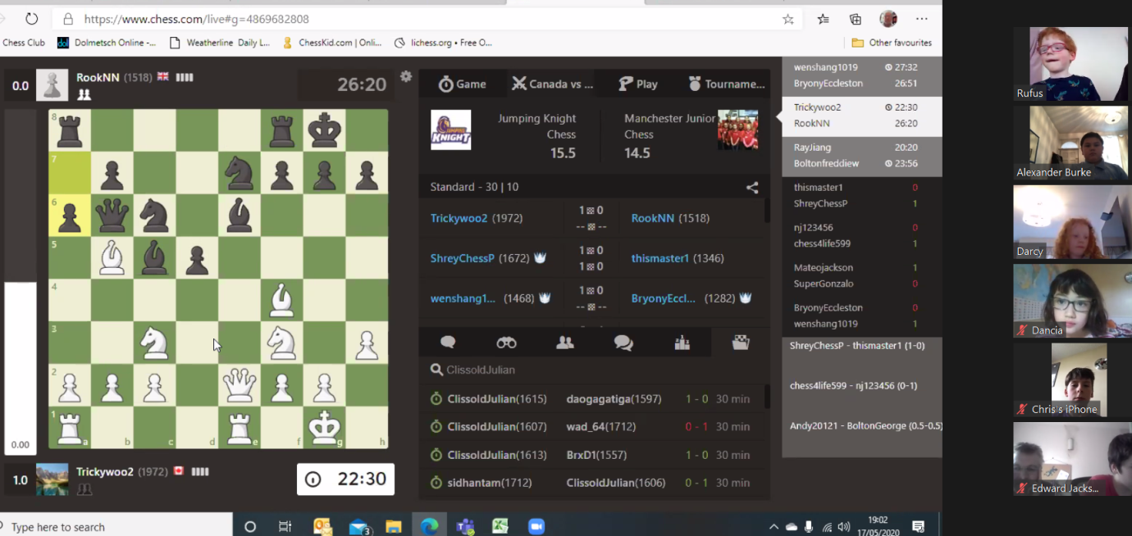

<https://www.chess.com/club/matches/live/manchester-junior-chess/11219>